03_02 Nested ifs

The if…elif statement looks like it is used for making many decisions and asks many questions since there are multiple conditions potentially being checked. For example:

if (number <0):
print (“Number is out of range”)

elif (number < 50):
print (“Number is less than fifty”)

elif (number < 75):
print(“Number is sort of high”)

elif (number < 100): #Can add brackets to improve readability
print(“Number is the highest!”)

else:
print(“Number is out of range”)

However, this is basically just 1 question – “What number is it”? The …elif structure just means there are several possible answers to the one questions (ie. 0 – 49, 50 – 74, 75 – 99, inclusive).

More complicated decisions may need to consider a 2nd question before finding a final branch. Consider the following chart, used to determine a letter code based on two things – a number and a colour.

Decision 1  Score | Decision 2  Colour | Action  Code
0 – 5 | Red | A
0 – 5 | not Red | B
6 – 9 | Red | B
6 – 9 | not Red | C
10 – 14 | not applicable | D

A score of 4, and the colour Red, results in printing A.
A score of 4, and any other colour, results in printing B
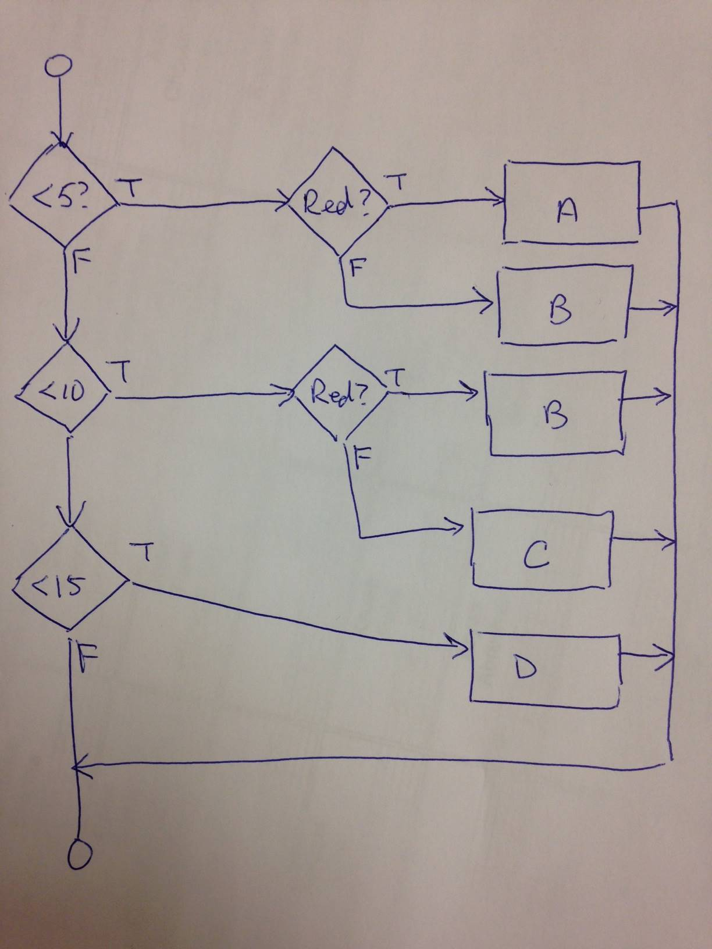
You can also get B with another combination, a score of 12 and Red

To the right is a flow chart for the task.

One method of dealing with multiple decisions is by nesting ifs. A nested if is an “if” statement written inside the branch or block of another “if”.
For the example above, the code would be:

1: if (number < 5):
2: if (colour == "Red"):
3: code = "A"

4: else:
5 : code = "B"

6: elif (number < 10):
7: if (colour == "Red"):
8: code = "B"

9: else:
10: code = "C"

11: elif (number < 15):
12: #Colour is irrelevant for this branch or outcome
13: code = “D”

These statements belong to the first decision (ie what’s the score)…
1: if (number < 5):
2: if (colour == "Red"):
3: code = "A"
4: else:
5 : code = "B"

6: elif (number < 10):
7: if (colour == "Red"):
8: code = "B"

9: else:
10: code = "C"

11: elif (number < 15):
12: #Colour is irrelevant for this branch or outcome
13: code = “D”

…these statements belong to the second decision to be made (ie what’s the colour), or the second step
(Note: I deliberately did not apply the convention of having a blank line after each block of code to make this code fit).

1: if (number < 5):
2: if (colour == "Red"):
3: code = "A"
4: else:
5 : code = "B"
6: elif (number < 10):
7: if (colour == "Red"):
8: code = "B"
9: else:
10: code = "C"
11: elif (number < 15):
12: #Colour is irrelevant for this branch or outcome
13: code = “D”

Finally, this is the third step in the branches.

1: if (number < 5):
2: if (colour == "Red"):
3: code = "A"

4: else:
5 : code = "B"

6: elif (number < 10):
7: if (colour == "Red"):
8: code = "B"

9: else:
10: code = "C"

11: elif (number < 15):
12: #Colour is irrelevant for this branch or outcome. Why?
13: code = “D”

Each indentation level indicates an equal level of logic, associated with having a decision evaluate to True, or having all previous branches being False

lines 1, 6 and 11 correspond to the first decision to resolve, about the number

lines 2, 4, 7, 9 and 13 correspond to actions after the first decision is evaluated (to a single True, or all False); 2, 4, 7 and 9 happen to be the second decision to resolve, about the colour

lines 3, 5, 8 and 10 are the resulting actions or processes that result after further knowing what was the colour;

What eventually happens when the program runs? It depends on what are in the variables “number” and “colour” at the time the program runs.

How many branches, or possible outcomes are there? The chart shows 5 possible outcomes : 4 in which both questions are answered, and 1 in which only 1 question needed to be answered.

You can have any of the if structures (if…else, if..elif, just plain if) nested in another.

Consistent indenting per nesting level makes for easier understanding of what the program does (recall, by convention, each block of statements that belong to one level should be indented the same amount).

Students with some previous programming experiences recognize multiple decision coding can be done using ANDs and ORs, but do not use them in this section – they will be looked at in the next section.

Organization of Programs

Organizing a program into functional (ie by usage) sections helps for future readability and maintenance. The following are general program organization conventions.
Header
Library imports
Define Constants
Define and initialize variables
Input statements
Processing statements
Output statements
A header is a common industry convention. It is a multi-line comment that includes :
- the name of the program
- the name of the developer
- the date the program was finished
- a short description of the purpose of the program
- in the industry, not for this class, a history of maintenance
All programs that are handed in must have a header.
There can be adjustments made to the general organization conventions depending on the program design. For example, if the input statements must be in a loop, then that is fine. Or if the input statements must be at the end of a loop.

You can “nest” up to 3 functions within each other.
Eg data = int (input (“Enter a number :”))
has 2 functions nested int() and input()

For readability convention, all complete round brackets should have a space before and after
Eg input (“Enter a number”) #yes
input(“Enter a number”) #no
if(not_liking_this == True): #no
if (not_liking_this == True) : #yes

eg.
#Name: Pay Calculator
#Programmer: Fred McGray
#Date: Sept20, 1902
#Description: The program calculates the pay for the Ideal corporation, using
# Canada Revenue guidelines, CRA bulletin 1203A

PAY_RATE_ENTRY = 0.12

worker_pay = 0
worker_hours = 0

work_ID = input (“Enter the worker’s ID”)
worker_hours = float (input (“How many hours did they work?”) )

#Calculations and stuff
:

print (“Pay for worker: “, work_ID, “ :”, worker_pay)

Nested ifs and program organization
Only use decisions with a single relational expression, and nested “if”s.
Advanced users, do not use ANDs and ORs for these programs – these will be covered later.

03_02_01:
Create a computer_trouble_shooting program that prompts the user if an ailing computer beeps on startup and if the hard drive spins. If it beeps and the drive spins, print “Contact tech support”. If it beeps and the drive does not spin, print “Check drive contacts”. If it does not beep and the drive does not spin, print “Bring computer to repair center”. Finally, if it does not beep and the drive spins, print “Check the speaker connections”.
Draw a flow diagram first, before coding.
Organize your program into sections as per the Organization of Programs convention. Include a header.
Hint: Can use a table to organize the possibilities. This would be written during the analysis part of writing programs.

Beeping | Spinning | Action
Yes | Yes | Contact tech support
Yes | No | Check drive contacts
No | Yes | Check the speaker connections
No | No | Bring computer to repair center

03_02_02:
A delivery service does not accept packages heavier than 27 kilograms or larger than 0.1 cubic meters (100, 000 cubic centimeters). Create a package_check application that prompts the user for the weight of a package and its dimensions. The program will check the conditions and print an appropriate message, for example, “package meets requirements”, “too large”, “too heavy” or both violation messages.

03_02_03:
Modify 03_02_02 so that users can be designated a Prime user. If the order is from a Prime user, and the order is for 900 copies or more, then they are entitled to a 10% discount on their final price.

03_02_04 :
Return to the first programming assignment (eg The Planner) and add a header and re-organize it with respect to the organization conventions.

03_02_05:
Write a program that composes a greeting to the user. The program will prompt the user for:
- name
- language (eg English, French) (optional)
You can use Unicode for your language if you know how.

The program will print a greeting either using the name or not. The program will prompt the user for a type of greeting to use:

- occasion for the greeting (eg birthday, Thanksgiving)

For example, outputs could be:
Hello, Francine. Happy Birthday.
Hello and Happy Birthday.
Bienvenue, Aziz. Joyeux Noel.

Use a nested IF structure – do not use AND or ORs

